PRT582 Software Project Plan
This project plan is worth 10% of this unit. Based on the requirements of the project and the agile testing quadrants, describe how you will be carrying out your tests and what sort of tests you will be conducting within the given timeframe.
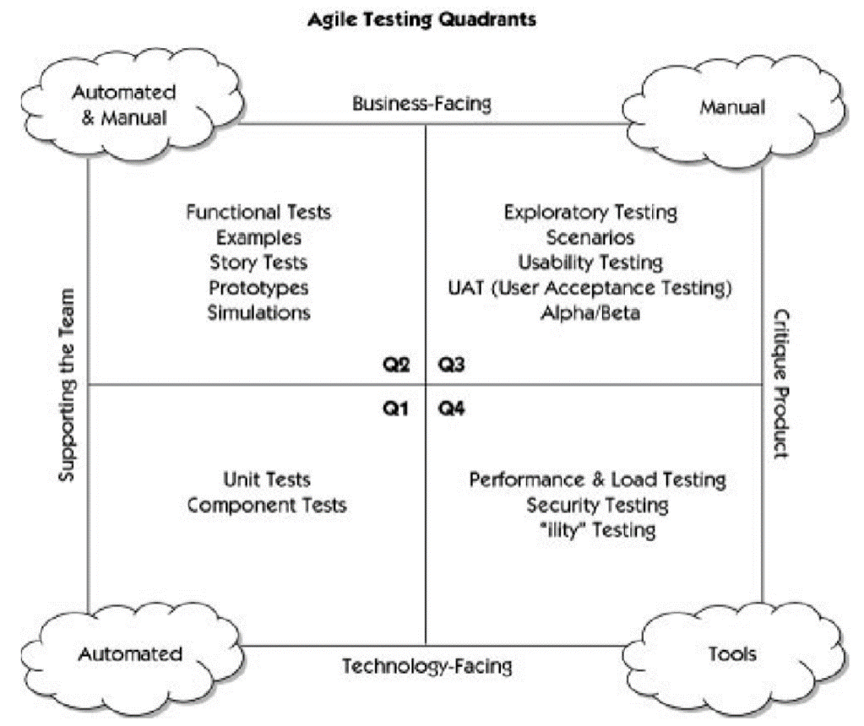
You can use the report format shown below:
Report Format:
- Cover page
- Content page
- Background
- Aims and Scope
- Requirements – list down the functional and non-functional requirements for the chosen project
- Agile testing – follow the agile testing quadrants shown above, stating the type of tests you will be conducting and how you will be doing them.
- Conclusion

The marking rubric is shown below:

